SAP Application Development

(S/4 HANA)

Analytical App Development

Motivation  This chapter will show you how to develop an analytical app based on OData and using the corresponding SAP UI5 controls. Therefore, you will learn how to make your entities from OData service consumable for the smart controls. | Prerequisites  Before starting this exercise, you should have fundamental ABAP programming skills and be familiar with the Eclipse IDE. Furthermore, it is recommended that you have completed the HTML5, CSS & JavaScript, SAPUI5, and OData chapters. The completion of the chapter SAP Fiori is also helpful.
Content  This chapter explains the necessary steps to build an analytical app. First, an OData service that provides the data for a simple chart will be created and exposed. Second, a web application to consume this service will be built in SAP UI5. In the next step a service, capable of providing the data for a smart chart will be created and configured. The application will be extended with the smart chart. Finally, the application will be deployed to the SAP backend. | Lecture notes  Students can go on with their accounts from the previous chapters mentioned in the prerequisites. If you skipped these chapters, your students may need to enter a developer key when creating their services. Please consult the lecture notes for further assistance on this topic. Furthermore, students should always use an individual three-digit number to mark their repository objects. In this exercise, these are displayed as ### and have to be replaced by the students’ individual numbers. In addition, please replace $$ with your two-digit institution id.

- Product: All

- Level: Advanced

- Focus: Programming

- Version: 2.0

- Author: UCC Technical University of Munich

Task 1: Implement the OData service for a simple chart
Short description: Using the integrated SAP GUI to create a new project in the Gateway Service Builder and generate the necessary runtime objects

Start Eclipse, and open the ABAP perspective. Open the integrated SAP GUI in Eclipse by clicking on , selecting an existing ABAP project and clicking OK. If you currently have no existing ABAP project, please refer to the Introduction to SAP Programming chapter on how you create a new ABAP project.

Open Gateway Service Builder
In the integrated SAP GUI, call transaction code SEGW, which opens the Gateway Service Builder. For this task we will use your existing gateway project Z_$$_###_FLIGHT that you have created in the exercise on OData. When you call the transaction, it should be already there. If not, click on Open Project , enter the project name, and click on Execute (in case you did not complete that exercise, create a project with this name. Refer to the aforementioned exercise if you experience any difficulties)
Switch to change mode by clicking on , otherwise you will not be able to create new entities. Expand your service and import the structure for the entity that we are going to use by right-clicking on Data Model and following the path Import DDIC Structure.

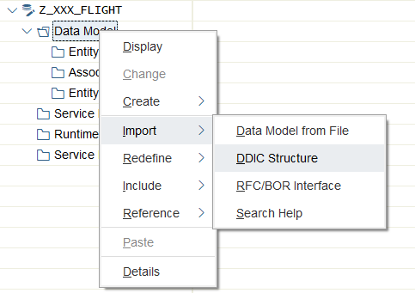
Our entity is called Sbook based on Entity Type SBOOK. Make sure that the “Create Default Entity Set” checkbox is checked.
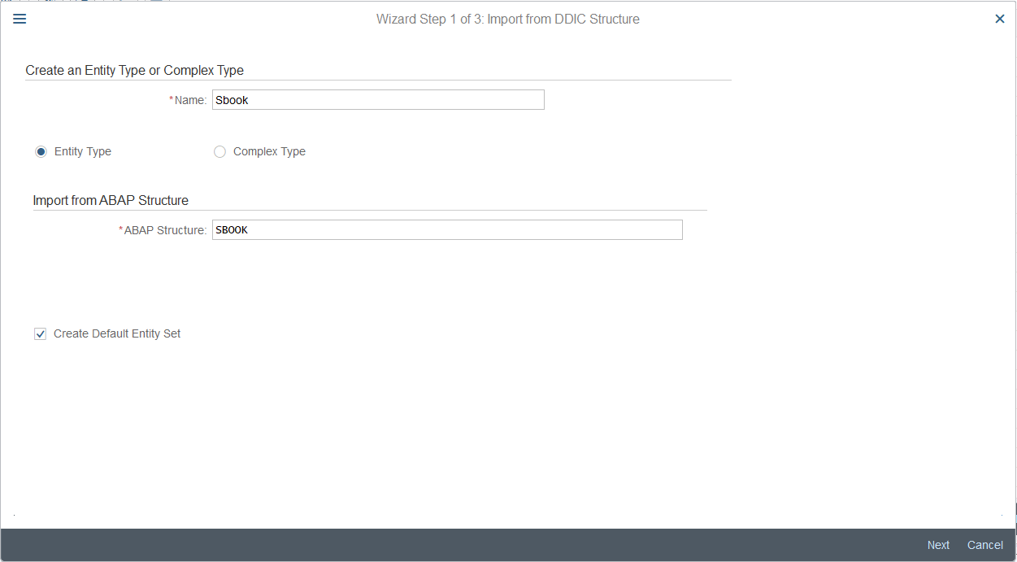
Since we are going to visualize the revenue per airline, select two fields – Carrid, and Loccuram, first containing the airline id, and the second one containing the cost of the single booking, stored in this table.
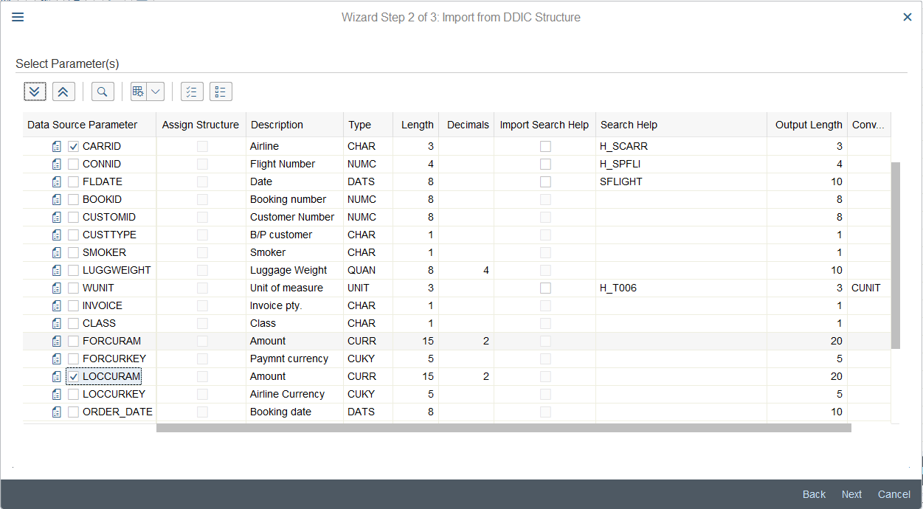
Mark Carrid as key and click on Finish.
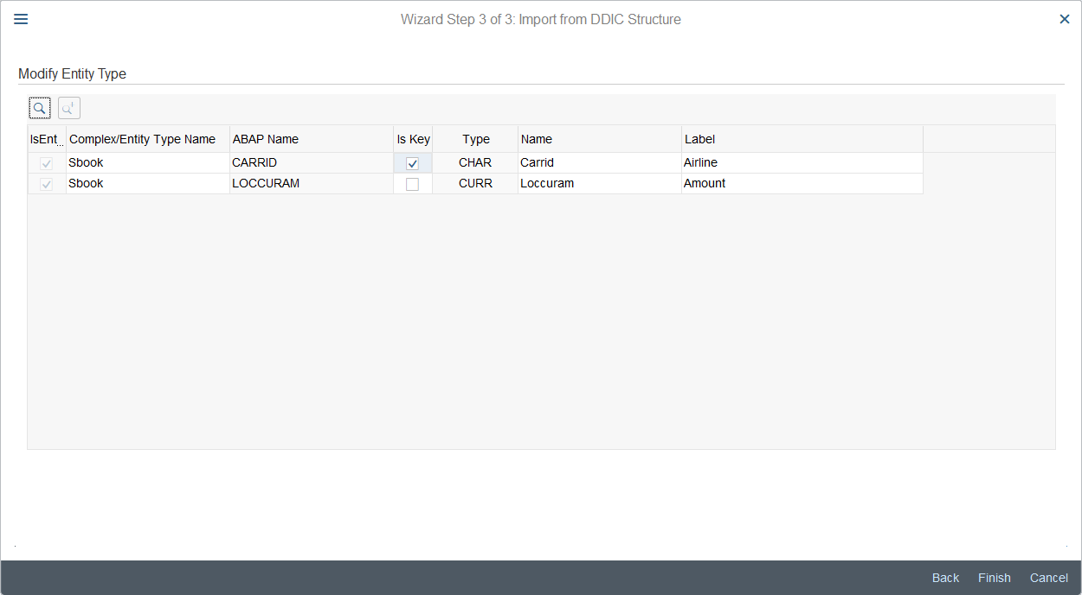
Save your project by clicking on Save and generate the runtime artifacts . Choose your transport request and leave the proposed class names without changes. Choose your package and the same transport request when prompted again. Your service is ready for the implementation now. Expand the runtime artifacts node, right click on your …DPC_EXT class, and select Go to ABAP Workbench.
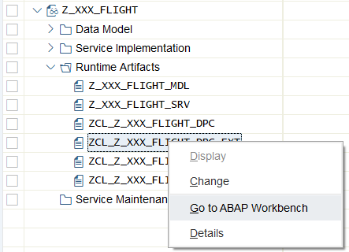
Since we are only going to read the data from the database and not make any changes, the only method we need to redefine is SBOOKSET_GET_ENTITYSET. Like all the CRUD methods, it has to be defined in the PROTECTED section. Add it after the previously defined methods, if you completed the OData exercise or at the beginning of the section otherwise.
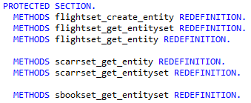
Add the method implementation. In this case we will be using the new Open SQL syntax to be able to write functions like SUM() or AVG(). This syntax requires the ABAP variables, referenced in the SQL call, to be escaped with @.
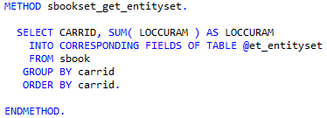
Save and activate your class.
Task 2: Test the OData Service
Short description: Test your OData service by looking at its metadata and at the result the OData model

Since we are using an existing OData project and an existing service, we do not need to activate it again. If you did not complete the exercise on OData, it would be necessary to activate the Z_$$_###_FLIGHT_SRV service. Refer to the Exercise 13 or the task 6 of this exercise for the instructions.
After the service has been activated, it will appear in the service catalog in the /n/IWFND/MAINT_SERVICE transaction. Since the re are lots of services on an S/4 HANA system, click on Filter , enter the aforementioned service name, and click Continue.
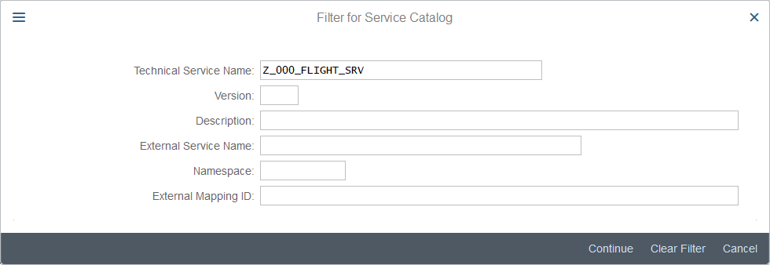
Your service will be the only one in the list.
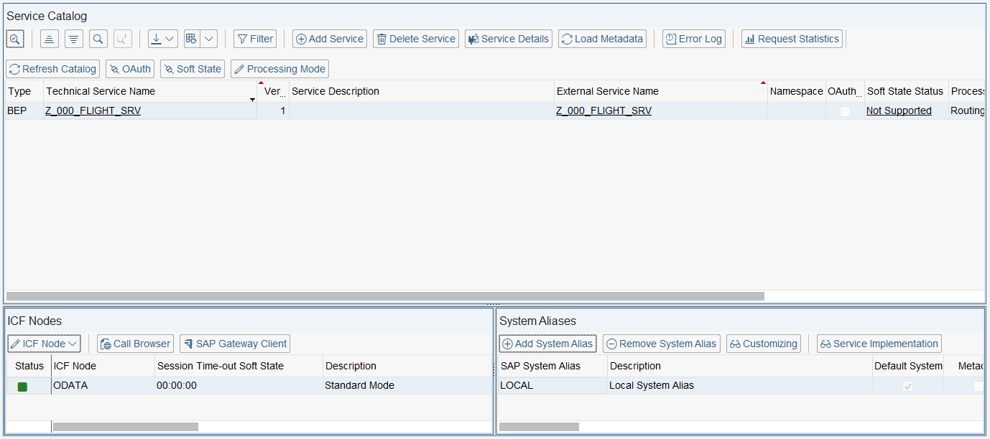
Select it and click on SAP Gateway Client . There you can test the service. First, view the service metadata. Use Add URI Option button to adapt the request URI.
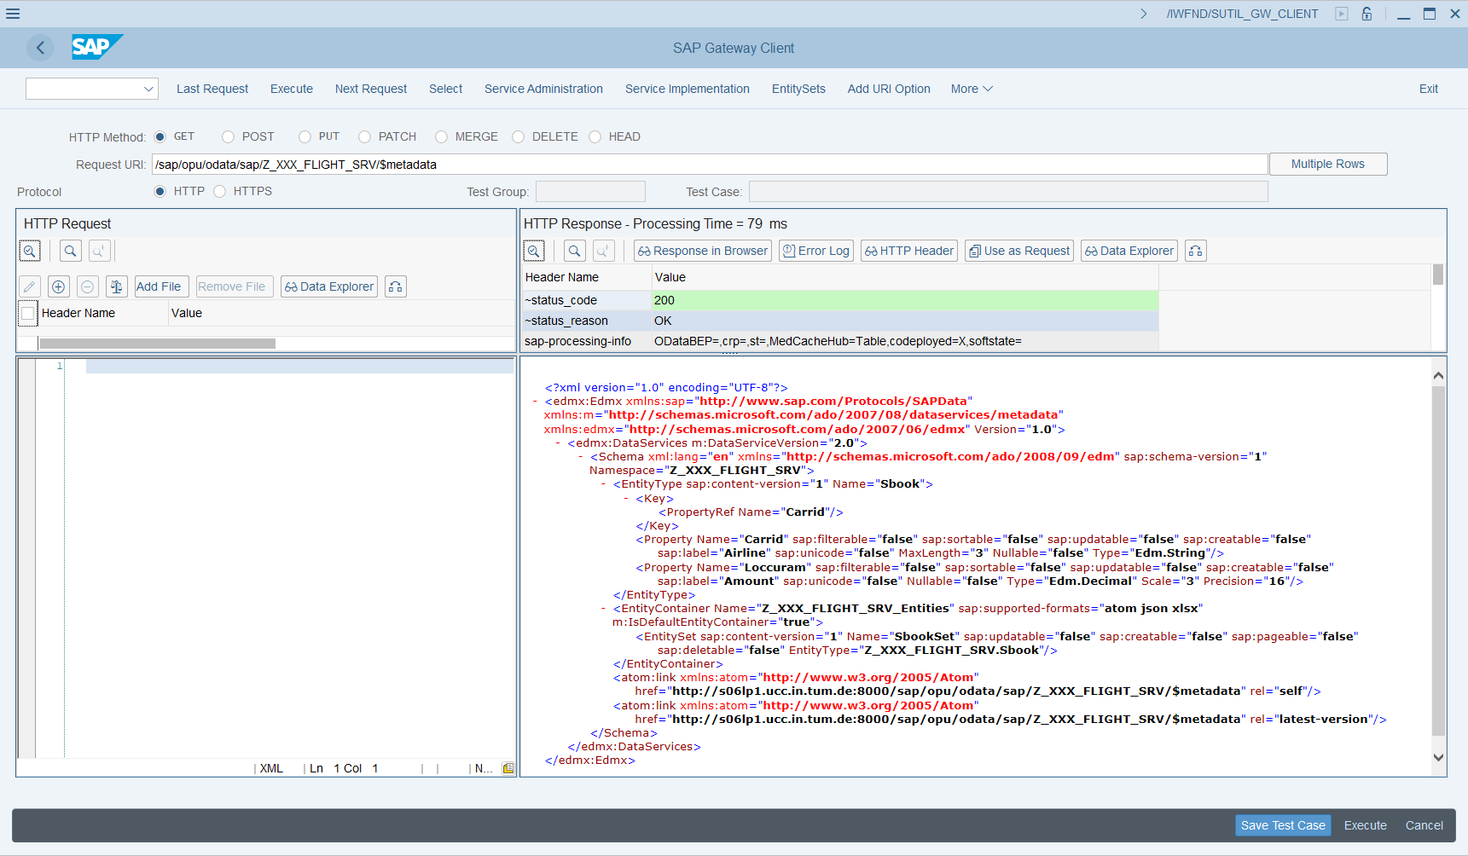
Now, display the contents of the SbookSet. Use Entity Sets button to add the set name to the request URI.
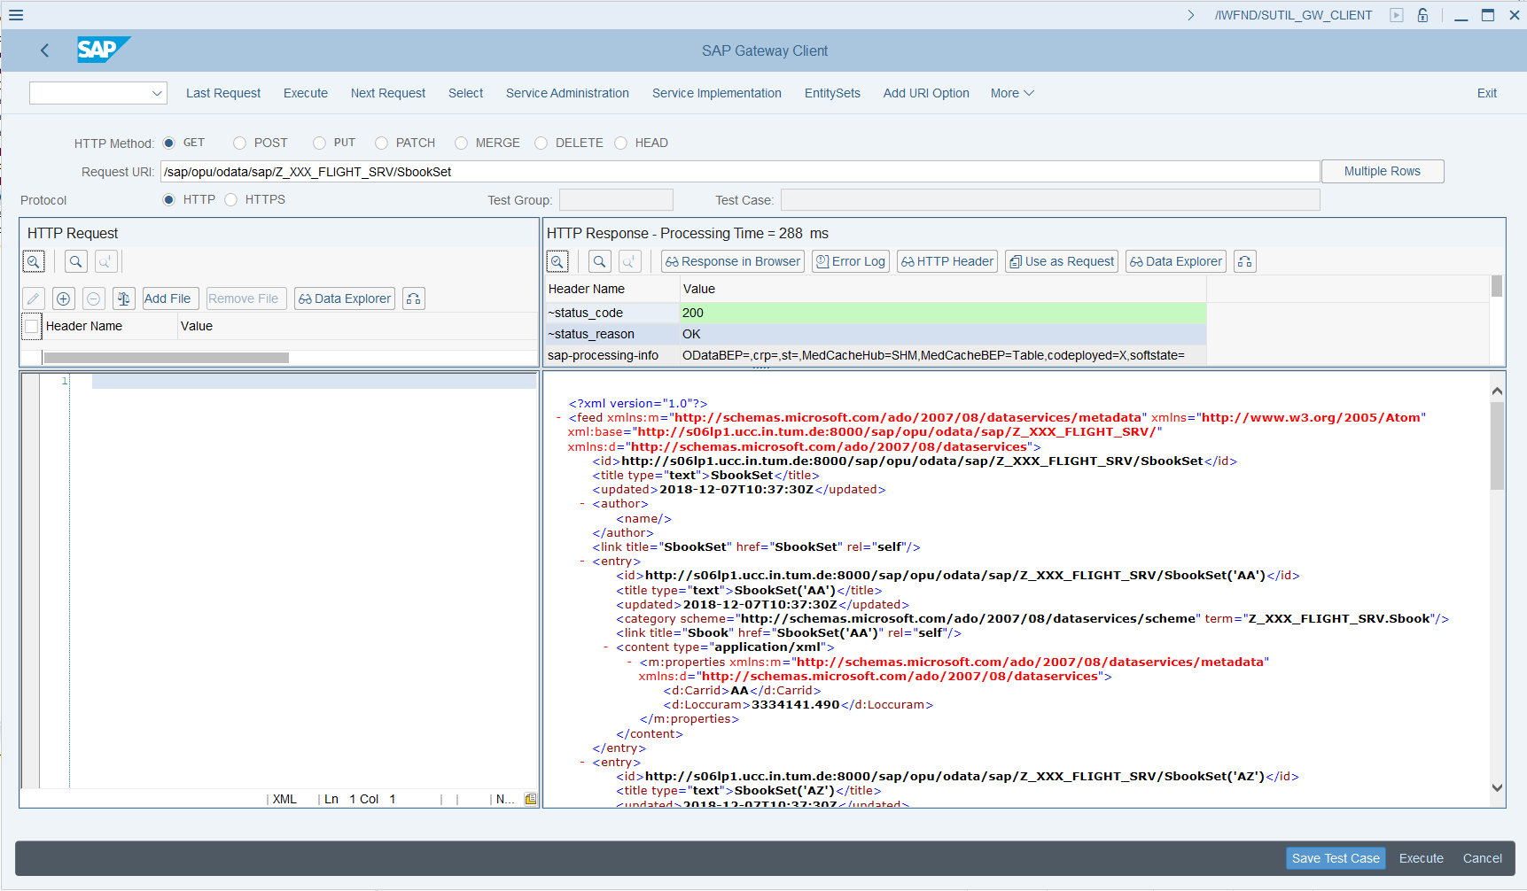
Task 3: Create a Fiori Component to consume the service
Short description: Creating a Fiori Component, containing a simple pie chart that visualizes the revenues of the airlines.

Back in Eclipse, we now want to create a SAPUI5 application which consumes our OData Services. In the context menu of the Project Explorer, choose New->Other->SAPUI5 Application Development->Application Project. Click Next.

Create SAPUI5 application
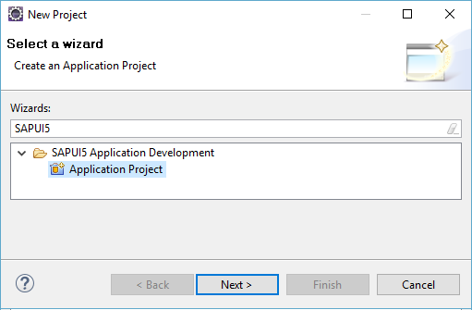

Give your project the name Analytics_App (no need to add your two-digit number at this point). Choose sap.m as library and check Create an Initial View and click Next.

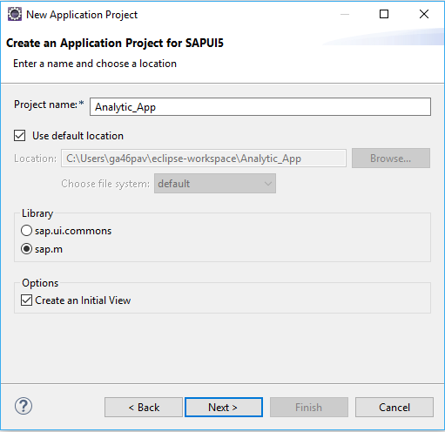

On the next page, you have to define the properties for your initial view. Enter the name main and select to develop the view using XML.

Create a new view
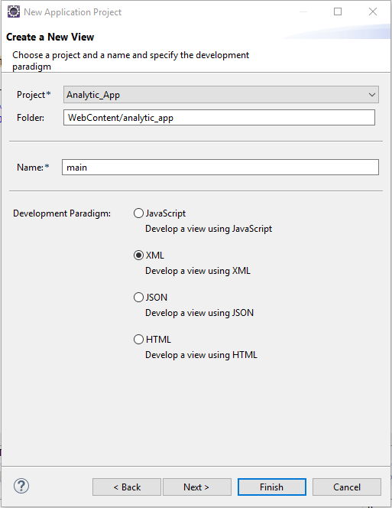

After the project has been created, change your folder structure as depicted on a screenshot below – create the view and controller folders, as well as Component.js and manifest.json files (ignore the error in manifest.json for now). Move the main view and main controller into the corresponding folders. Delete the analytics_app folder.
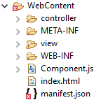

Make the necessary changes to the index.html file (replace 000 with your number). Pay attention to the src property in the script definition. This time we are not using the UI5 libraries installed on the server, but load them from the SAP repository to make sure that we have a version, compatible with the controls we are using.
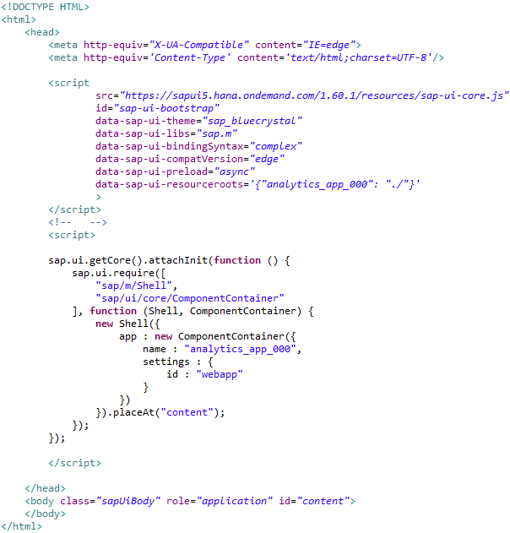

Define your component in the Component.js. Again, replace 000 with your number.
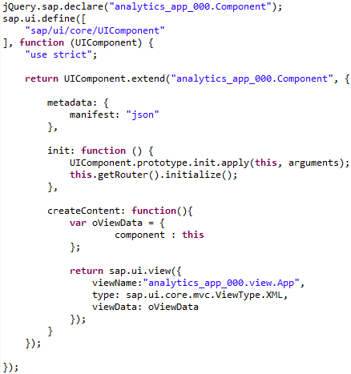
Implement the application metadata in the manifest.json file. Again, replace 000 with your number and use your service URL when defining a data source.
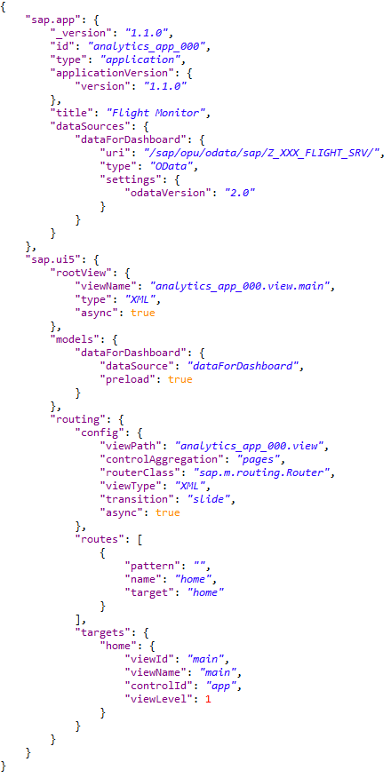
The only missing file to make the project runnable is App view. Like in the OData exercise, no controller is needed.
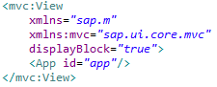

Now open the main.view.xml. Here we will display our charts. At first, change the controller name, replacing 000 with your number:
After that change the title of the application to Dashboard by editing the title property of the Page element. To display the chart, we will use the FixFlex container element. It is divided into two sections – fix content and flex content. Fix content will contain the control panel of the pie chart, and the chart itself with the corresponding chart container will belong to the flex content. Define the component in the Page content.

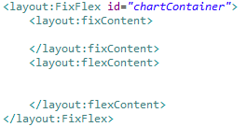
Now, define the chart inside of a flex content.
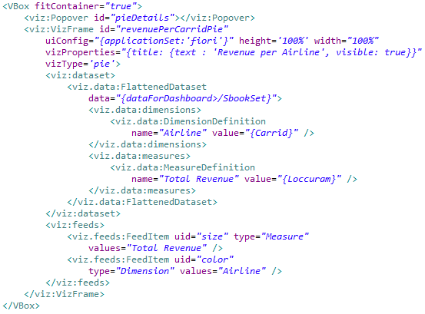
Define the switch that allows to display the percentage on the chart in the fix content section.
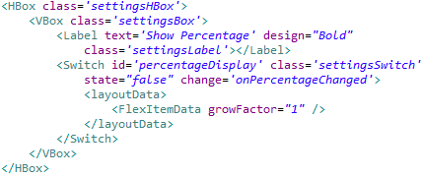
Add the required dependencies to the header of the view definition.
The view is now ready, we just need to save it by clicking on one of the Save buttons and to implement the application logic. Open the main controller file and define it as depicted below.
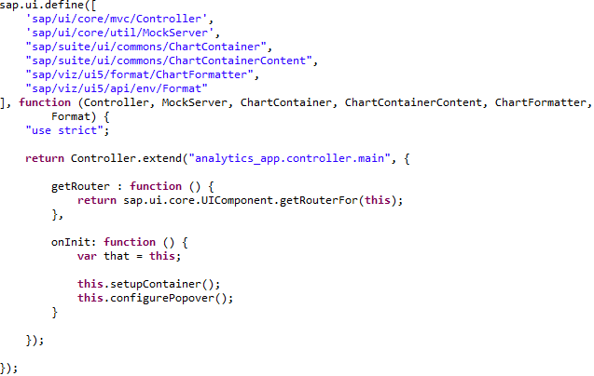
You might notice that a lot of dependencies have been imported into the controller. They will all be necessary later. For now, you have defined a function getRouter(), necessary for the in-app navigation, and called the two set-up functions in the onInit method. Now we are going to implement these functions.
As presented in the slides, the charts from the viz-library have no toolbars or any interaction possibilities active per default. To enable them we need to place the chart in a chart container. This is done programmatically – implement the function setupContainer after the onInit:
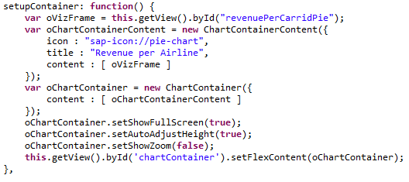
Now setup the popover, that will be displayed when the user clicks on a value in a pie chart:
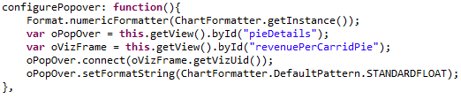
In the last step, program the event handler for the switch in a way that when it is switched on the percentage labels are displayed on the chart.
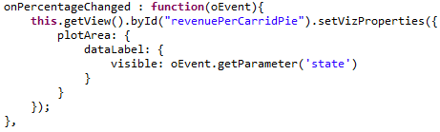
Finally, save your JavaScript file by clicking on .

Task 4: Deploy your application to the SAP backend
Short description: Deploying the application to the SAP backend to make it accessible on the server

Deploy application to SAP backend
To deploy your application to the SAP backend, right-click on your web project in the project explorer and choose Team->Share Project. In the next step, select SAPUI5 ABAP Repository as repository type. Afterwards, choose your system connection, and enter User and Password if necessary. Next, define to create a new BSP Application. Enter Name Z_$$_###_Analytics, a description, and your Package to which you want to assign your application. Click Next.

Submit repository objects
Choose a transport request. Again, you may use your default transport request you used for other exercises. Click on Finish. The application will be deployed to the SAP backend. If you encounter any difficulties when deploying, consult the exercises on UI5 and OData.

To test your application, first make sure that all source files were correctly submitted. For this, right-click on your project, and click on Team->Submit. Choose all your files and click on Finish. If submit is already greyed out, everything is fine.

Finally, right-click on your project, and choose Run As->Run on ABAP Server.

Test your application
You may need to login with your username and password. Afterwards, your application will be displayed in the integrated web browser. There, you will see your pie chart. If you want to view your application in the system browser (like for debugging purposes), you can click on .

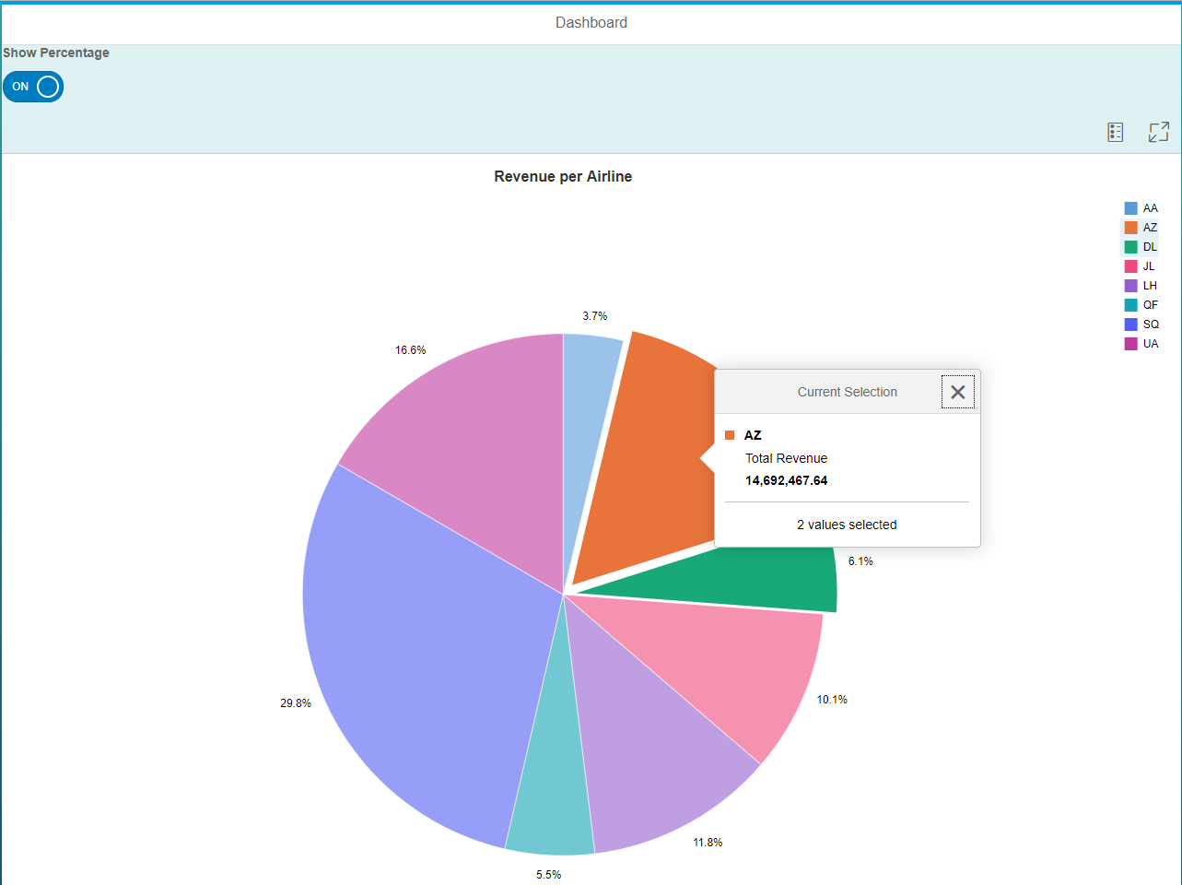

Loading all the necessary data might take some time. When you see the chart, experiment with the percentage switch, toolbar buttons, and with clicking on the chart elements.

Task 5: Develop a service for a smart chart
Short description: Develop another OData service and annotate it to make it consumable by the smart UI controls, such as smart chart.

In the integrated SAP GUI call transaction code SEGW again and create a new project, called Z_000_ANALYTICS. Be sure to choose the project type “Service with Vocabulary-Based Annotations”.
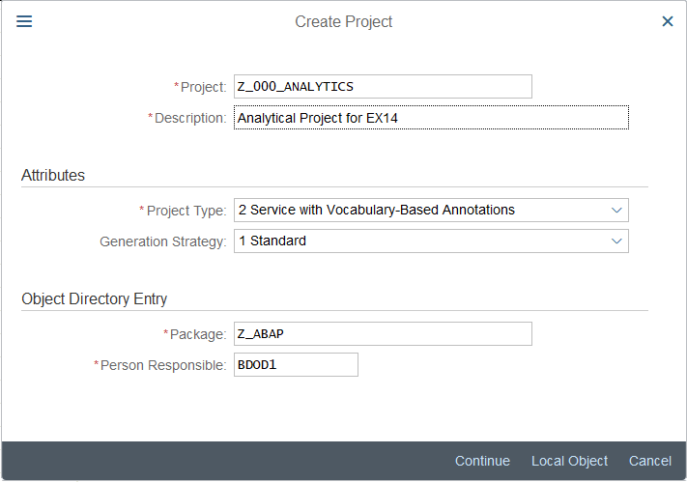
Expand the newly created project, right-click on Data Model, and import a Vocabulary.
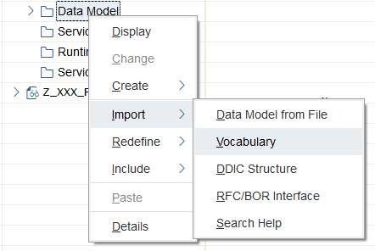
In the next window choose the last entry, /IWBEP/VOC_UI, and click Continue.
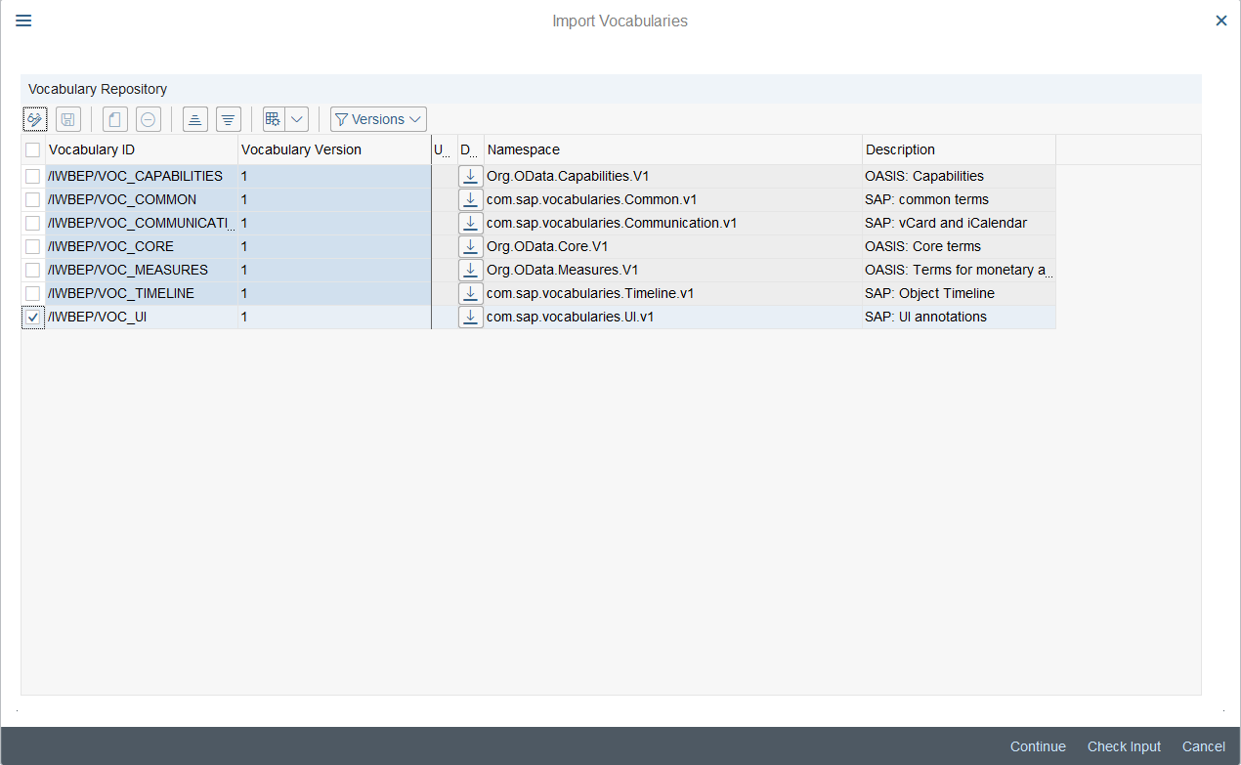
Now, create a new entity like in the task 1. Call it Savgprice and base it on the ABAP structure SBOOK. Select only Carrid and Connid from the list of the fields and mark them both as keys. In this chart we will display the average price per airline and connection, and we will add the necessary field manually. Expand the Entity Types node and the newly created type. Double-click on properties and you will see both Carrid and Connid in the table on the right. Create a new property by clicking on Append Row . Call it Loccuram of type Edm.Decimal with precision 15 and scale 2 as well as LOCCURAM as ABAP Field name.
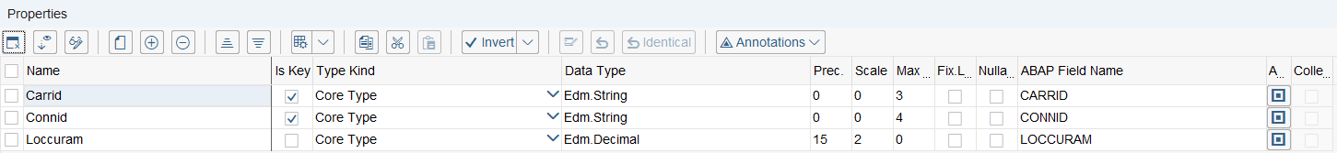
Save your project and generate runtime artifacts.
We will need the query method to fetch the data from the database like we did in the previous tasks. Again, right-click on the …DPC_EXT class, and choose “Go to ABAP Workbench”. Define the query method in the protected section:
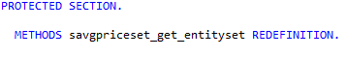
Implement the method. Here you have to select the average price from the table SBOOK, based on the two key fields, Carrid, and Connid, and group the results by both key fields.
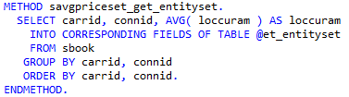
Save and activate your class.
This implementation is sufficient for the simple chart. But since we are planning to use a smart chart, we need to define our metadata. It is possible in the SAP gateway, but this method is time-consuming and not very reliable. That is why we are implementing the necessary annotations in the …MPC_EXT class. Open it in ABAP workbench.
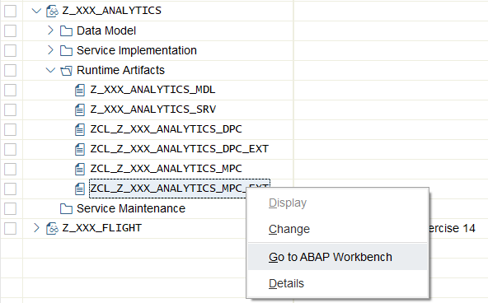
We are going to redefine two methods: DEFINE and DEFINE_VOCAB_ANNOTATIONS. The first method is public, and the second is protected.
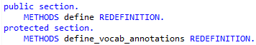
First, we are going to define the semantics for our entity type – it is an aggregation. Its fields need an aggregation role. Carrid and Connid will act as dimensions, and Loccuram is a measure. Implement the DEFINE method:
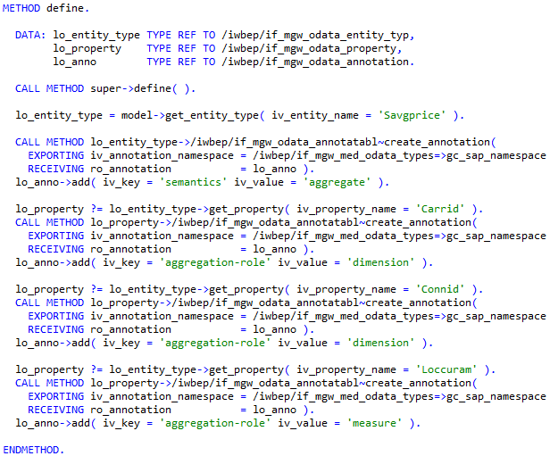
Now we need to create the annotation for the chart. Define the chart title, description, and type, as well as the lists of measures and dimensions. Pay attention to your number when setting the namespace qualifier.
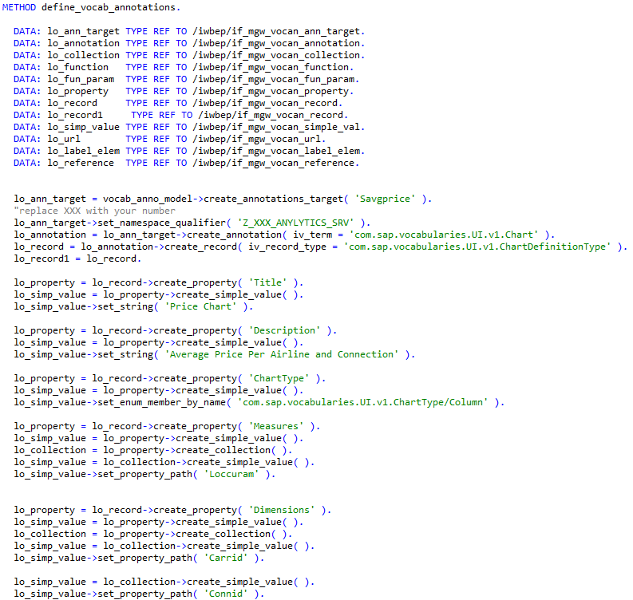
Continue with the method implementation – define the measure attributes and dimension attributes, such as the roles and the paths to each attribute inside of the entity. Both of our dimensions are categories, and the measure should belong to Axis1.
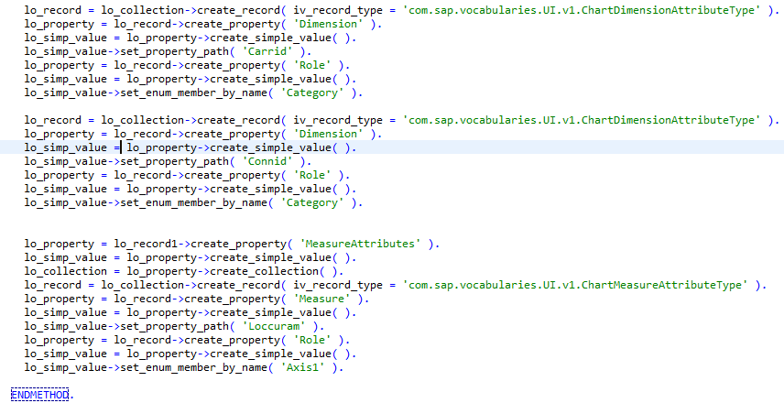
Save and activate your class.
Task 6: Activate the service and check the metadata
Short description: We have developed an OData service and annotated it so that the smart chart can understand the data, fetched via that service. To be consumable, the service needs to be activated. It is also necessary to check whether the annotations have been understood correctly and whether they are depicted correctly in the service metadata.

To activate the service, open the /n/IWFND/MAINT_SERVICE transaction. There click on Add service . In the opened window enter LOCAL as System Alias and Z_XXX_ANALYTICS_SRV as Technical Service Name (replace XXX with your number), and press Enter. Your service should be listed in the selected services section. Click on the line with it and click on Add Selected Services 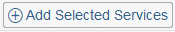.
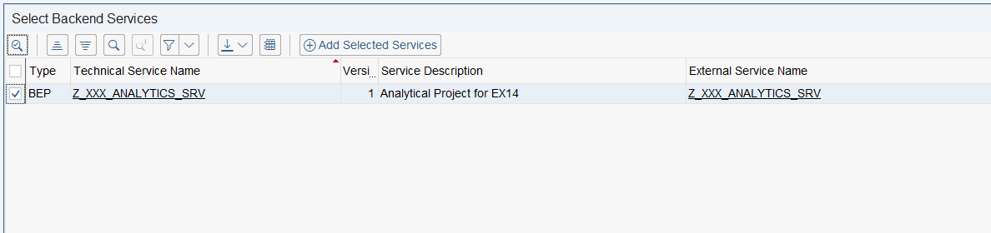
In the next window leave the names without changes and select your package. When prompted for the transport request, make sure that your request is selected. After receiving a success message click Continue. Click on Back to return to the service catalog. Find your service in the list (or alternatively filter for it), and select the line.
In the bottom part of the screen click on SAP Gateway Client . There we have to check the metadata of the service. Add the $metadata to the URI and click on Execute.
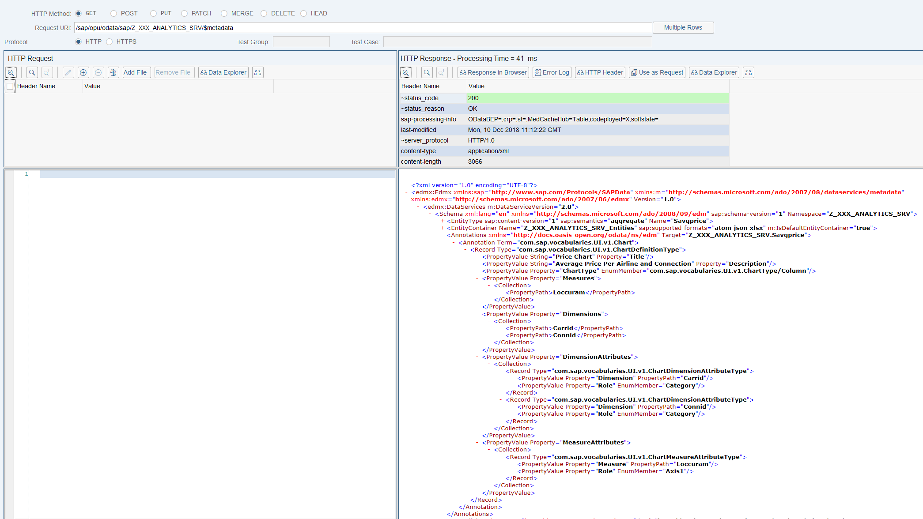
You can see the correspondence between your implementation and the results of your call. The annotation for the chart is located under the entity type and the entity container definitions.
Task 7: Extend the UI5 application with the smart chart
Short description: We have a running UI5 application, depicting the revenue per airline in a form of a pie chart. We have also developed and activated an OData service that can provision the data for a smart chart. Now the application has to be extended with this UI control.

First step is to declare a new data source in the manifest.json file and to reference the data source in the default data model. Add the dataForChart data source and default (“”) model. Be sure to use your own service.
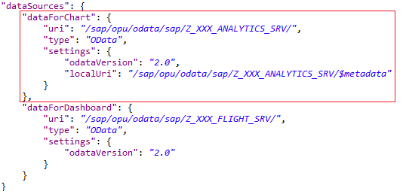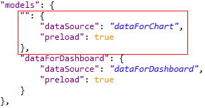
Add the control definition to a view after the FixFlex:
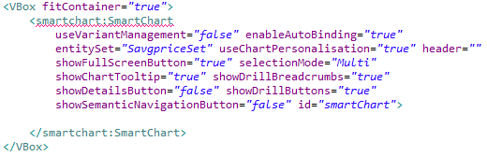
Resolve the error by adding a missing dependency to the view header:
The last step is to fetch the data from the database. In the onInit function of the controller, perform the query method against the defined set, and start the mock server to serve the data to the smart chart if the result has been successful:
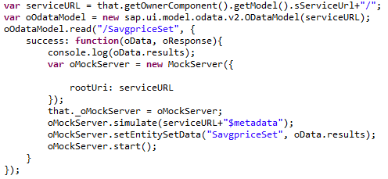
Unlike the OData exercise, where we’ve defined a service URL in a separate file, here we load it directly from the controller metadata. This value gets populated from the manifest. After querying the database, we use the API of the mock server to add our data to it and to start it.
Save all your files and submit your changes to the backend. After that start the application. For the best experience, open it in browser. You should see the smart chart underneath the pie chart.
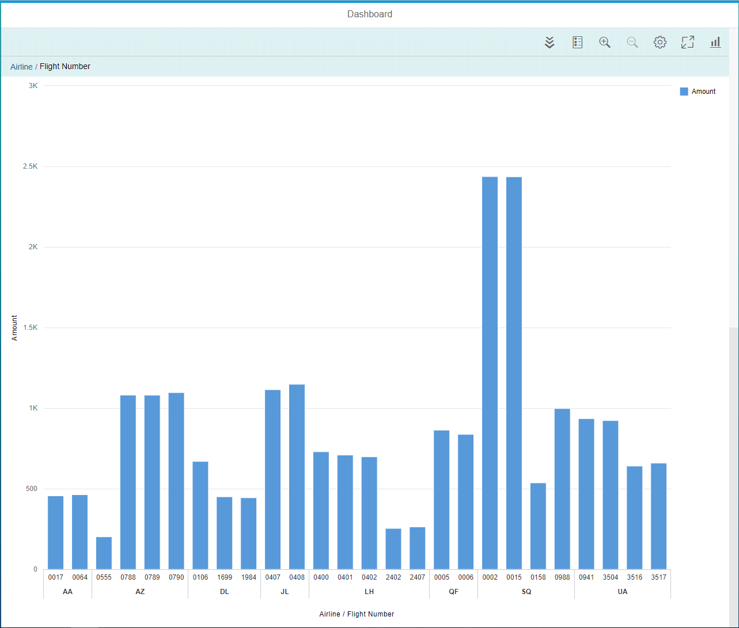
Experiment with the roll-up and drill-down buttons:
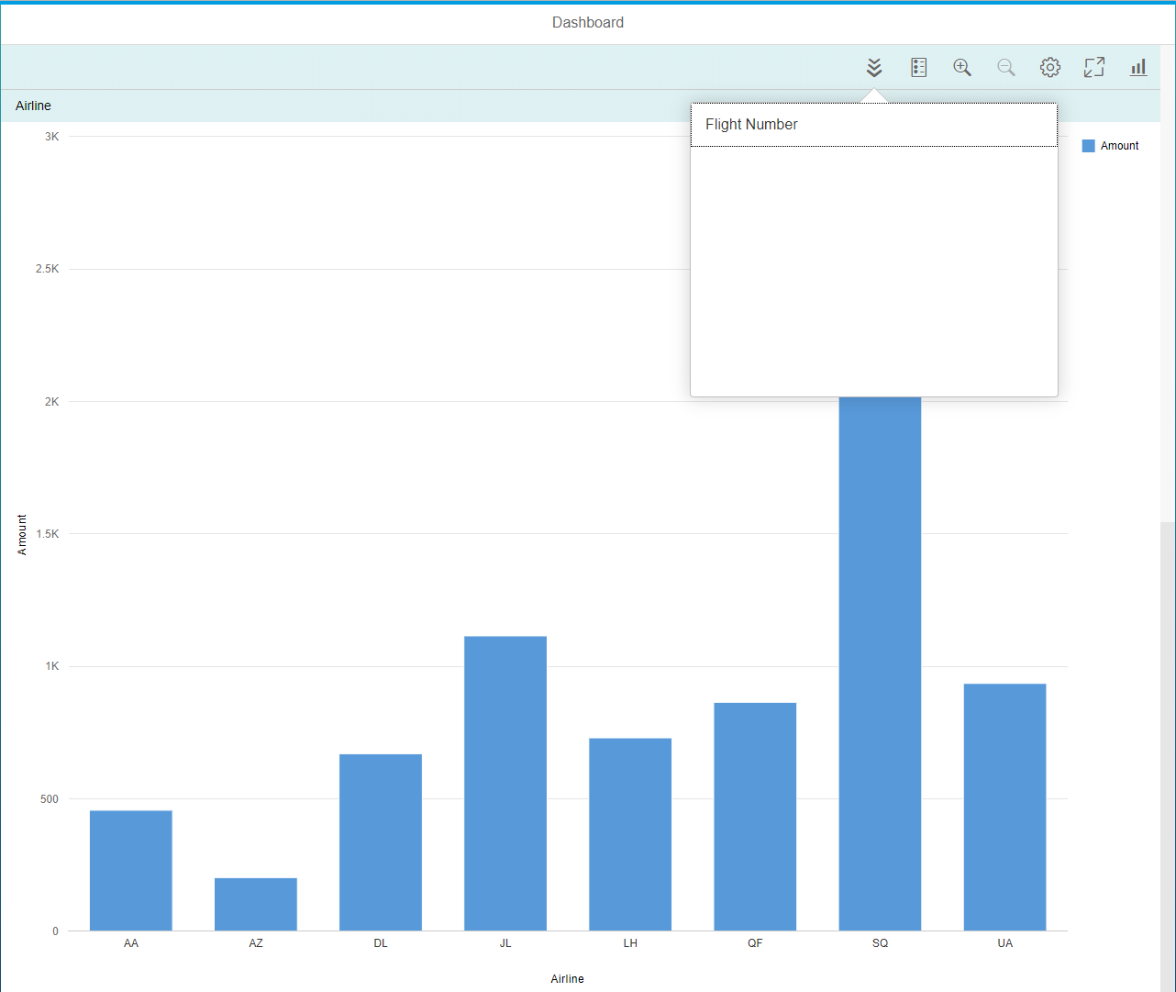
Try out the sorting and filtering options (press on Settings ):
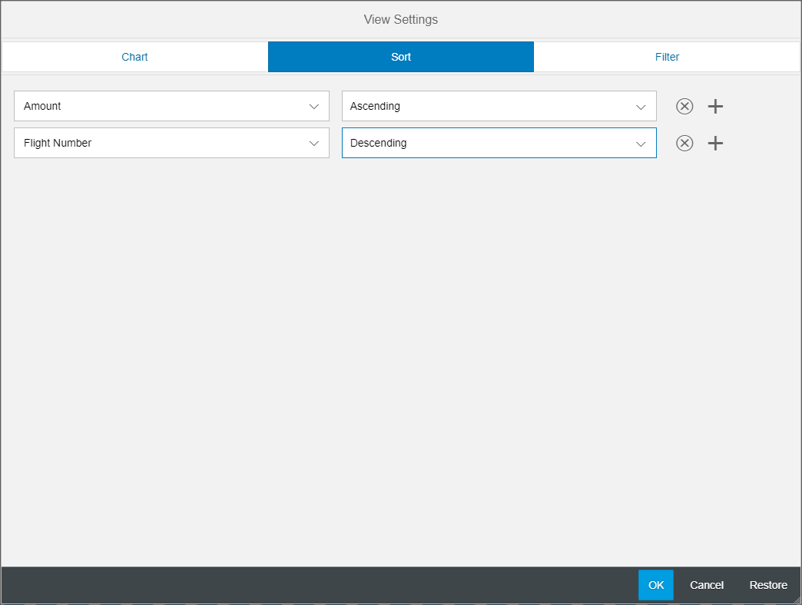
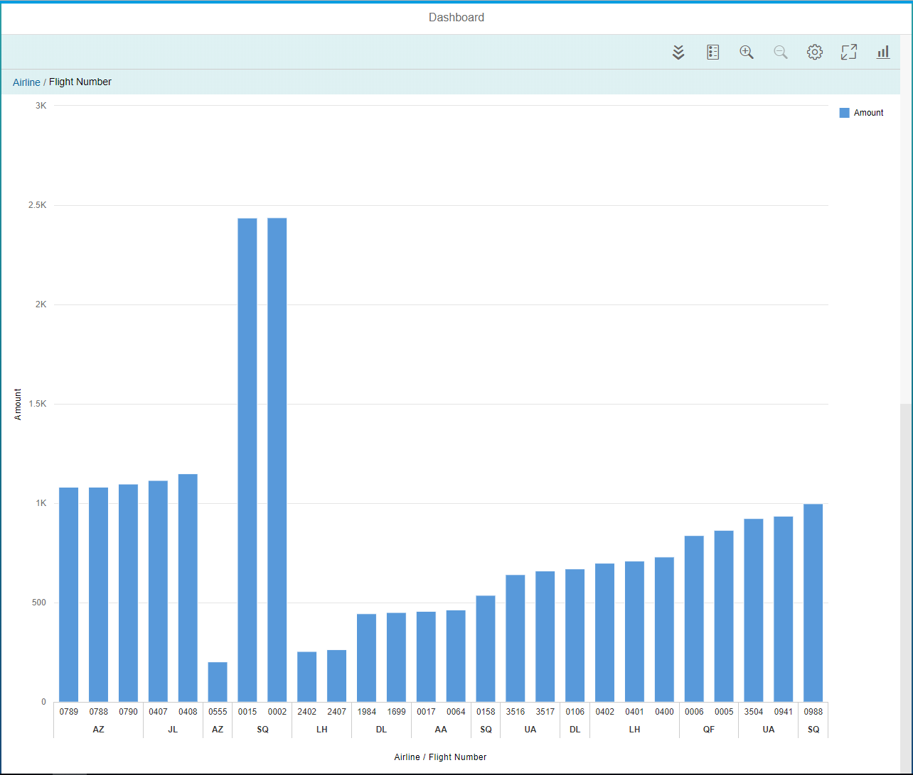
You can also change the chart type by pressing on . Convert it to a bar chart:
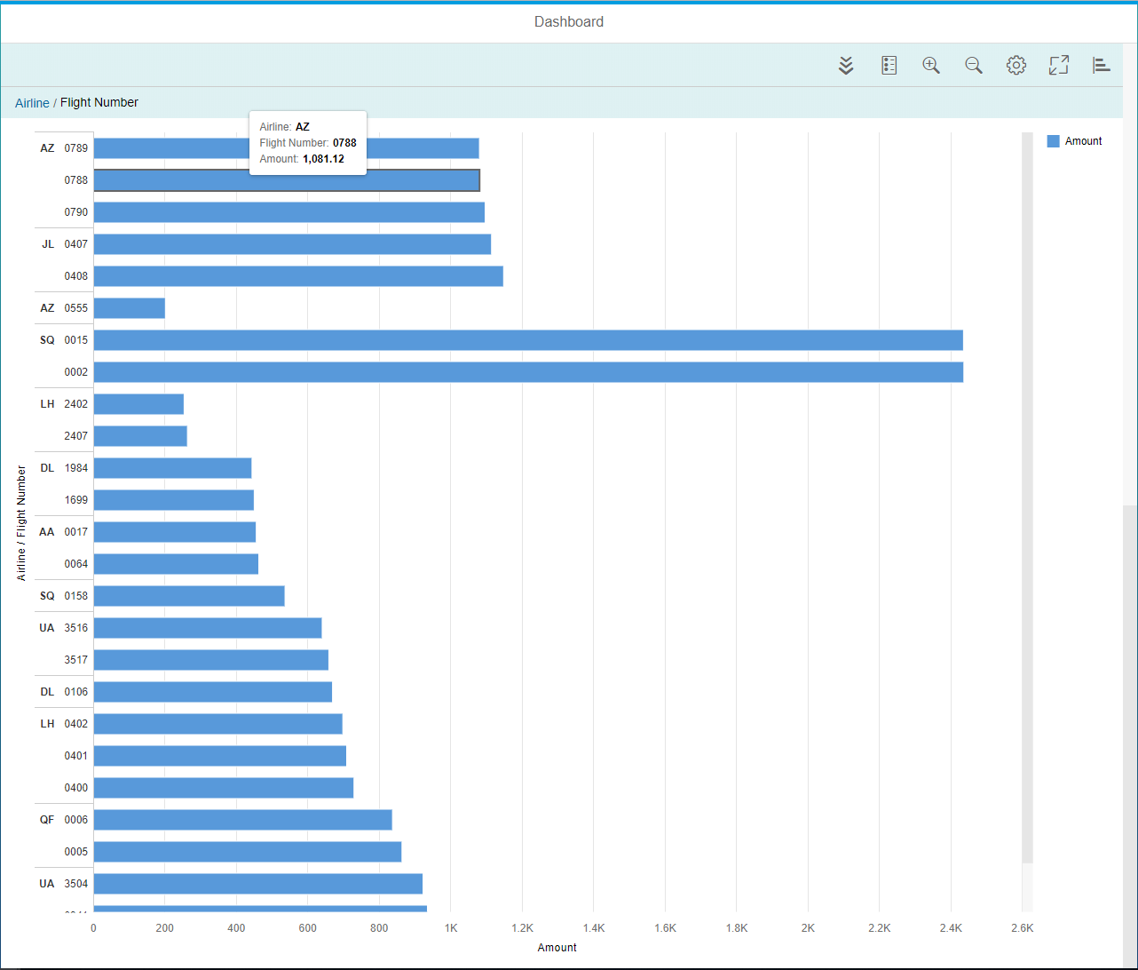
Challenge: Modularize your application
Currently we have developed both charts in one view, strictly following the blob development anti-pattern (http://antipatterns.com/briefing/sld024.htm). This is a bad practice, that is why you have to modularize the application. Create a structure, similar to the SAP UI5 exercise – a main view with two buttons, “Show Pie Chart” and “Show Smart Chart”. Move the charts from the main view into an own view. Implement navigation using hashing, and enable navigation to the respective view when clicking on the button.

